DBF & MC ASSIGNMENT 2020
Remote Artisan App
Tristan Bookhan(2105569) and Sheslin Naidoo(2094701)

General description

Artisan FAM is a remote artisan app. It is designed to help people who require the help of artisan’s specific skills during lockdown but are not able to call the artisan out to physically be at your home.
The app allows you to search or a specific artisan by either job name, actual name or by artisan type. Once you have found an artisan you will e able to view their personal information, comments from recent customers and you can email/voice call or video call the artisan. Once you have contacted an artisan, the artisan has been hired by you, you can then comment and rate about how help the artisan was.
If you are an artisan once a customer has gotten in contact with you, you have been hired and are able to view the customers profile and comment and rate the customer. An artisan will have to choose their expertise on registration, and it cannot be changed thereafter. An artisan is also a customer and has access to all the features that a customer would.
There is a general chat option available for anyone who wants to just offer help without being hired by a customer.
A customer or artisan will have to have a email address or phone number in order to register an account for the app.
Both artisans and customers have the option to update their profile at any time.
Features:
The app has auto log capabilities after you have logged on for the first time.
If you want to get into contact with an artisan there are many ways you can do so by simply pressing a button in the app. If it is through email the app will automatically open your default email app and enter in the artisans email address, if it is a phone it will open our phone app and enter in the artisans phone number and if it is a video call if will start a WhatsApp video call with the artisan.

Formulation of Business rules

- Each user has a unique account. Each account is linked to only one user.

- Each user has a name, surname, user type, password and either a unique email or phone number or both.

- A user can update their information. Information for a user can be updated by said user.
- A user is a customer. A customer is a user.

- An artisan is a user. A user can be an artisan. A user is not required to be an artisan.

- Each artisan has an artisan type, business name, description and an average rating.

- An artisan can update their description. Description for an artisan can be updated by said artisan.

- A customer may hire many artisans. An artisan may be hired by many customers.

- An artisan may write a comment or rate on how pleasant a customer was. A customer can view the comments made by an artisan.

- A customer may write a comment or rate an artisan on how helpful and polite they were. An artisan may view the comment.

Initial development of ERD

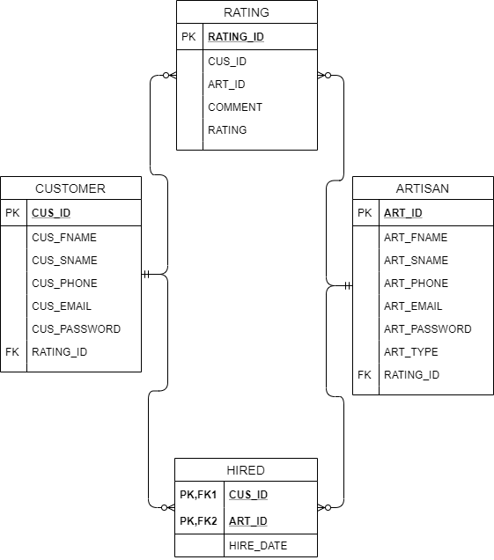

Thought process
A user can either be an artisan and a customer, so each user type has a table with their defining characteristics.
A customer should be able to hire an artisan. So, a table storing the customer ID and person ID who was involved in the hiring process. The tables would also need to have a relationship to the hired table, which would be a 1:M relationship.
A customer can comment and rate an artisan’s helpfulness and an artisan can also rate and comment on how polite customers were. A table was created to store all comments and ratings from either a customer or artisan. And the relationship from RATING table to users table would be 1:M .

Recognition of issues
INTIAL ERD
An artisan can also be a customer, so then an artisan will also have to create an instance in the customer table. This will use up storage and there would be a lot of redundant information being stored.
Since CUS_ID and ART_ID are primary keys in HIRED table a customer can only hire an artisan once.
Since ratings and comments for both artisans and customers are stored in the RATINGS table there is no way to tell who the author of a comment and rating is and who the comment and rating is directed to.
The RATING_ID was stored as a foreign key in the user’s tables so that meant a user could only store their most recent comment or rating in their profile.
Any customer or artisan could comment on another artisan or customer since ART_ID and CUS_ID where foreign keys of ARTISAN and CUSTOMER.
FINAL ERD
*Final ERD on next page
If a customer decided not to enter a email or phone number the space would be left blank (not NULL). This was still considered as an entry by the DBMS.
Storing a artisans average rating vs calculating it on request.
Updating an users information, especially the primary key (PER_PHONE,PER_EMAIL) was an issue to update.

Final ERD
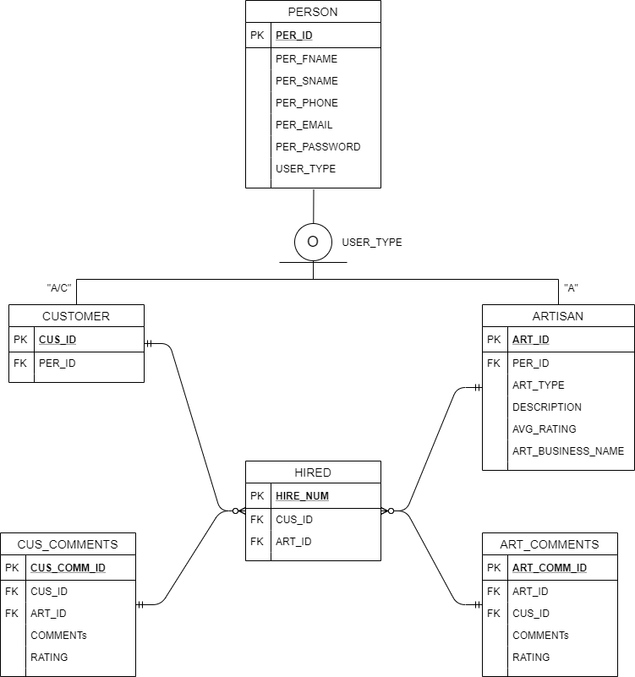

Solutions to all issues encountered

We created a supertype PERSON so when a user is created their defining details are entered in PERSON table. Then we created two subtypes CUSTOMER and ARTISAN.
We created a surrogate key in the hired table and made CUS_ID and ART_ID foreign keys. Now a customer can hire the same artisan more than once.
The RATINGS table was removed and CUS_COMMENTS and ART_COMMENTS was created in its place. CUS_COMMENTS stores comments written by customers to artisans and ART_COMMENTS stores comments written by artisans to customers. It is now easy to identify who wrote a comment and who the comment is directed to.
ART_ID and CUS_ID are stored in both CUS_COMMENTS and ART_COMMENTS so a customer/artisan will be able to view all comments they have previously written.
The CUS_COMMENTS and ART_COMMENTS are now foreign keys of the HIRED table so the only way for a customer or artisan to comment on another customer or artisan is if the artisan was hired by the customer.
A trigger was used to fix the NULL problem with storing empty values as primary keys.
We decided to store the average rating and update it using a trigger and procedure after a new comment/rating is added.
When a user updates their primary key, we first check if the primary is already linked to another account.

Implementation of tables, procedures and triggers

*php files included in project folder
Tables used:
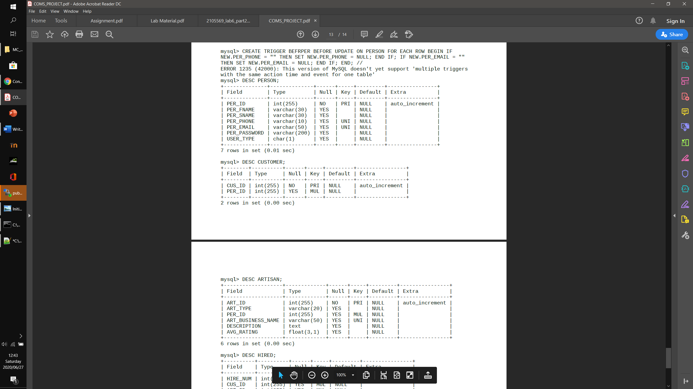
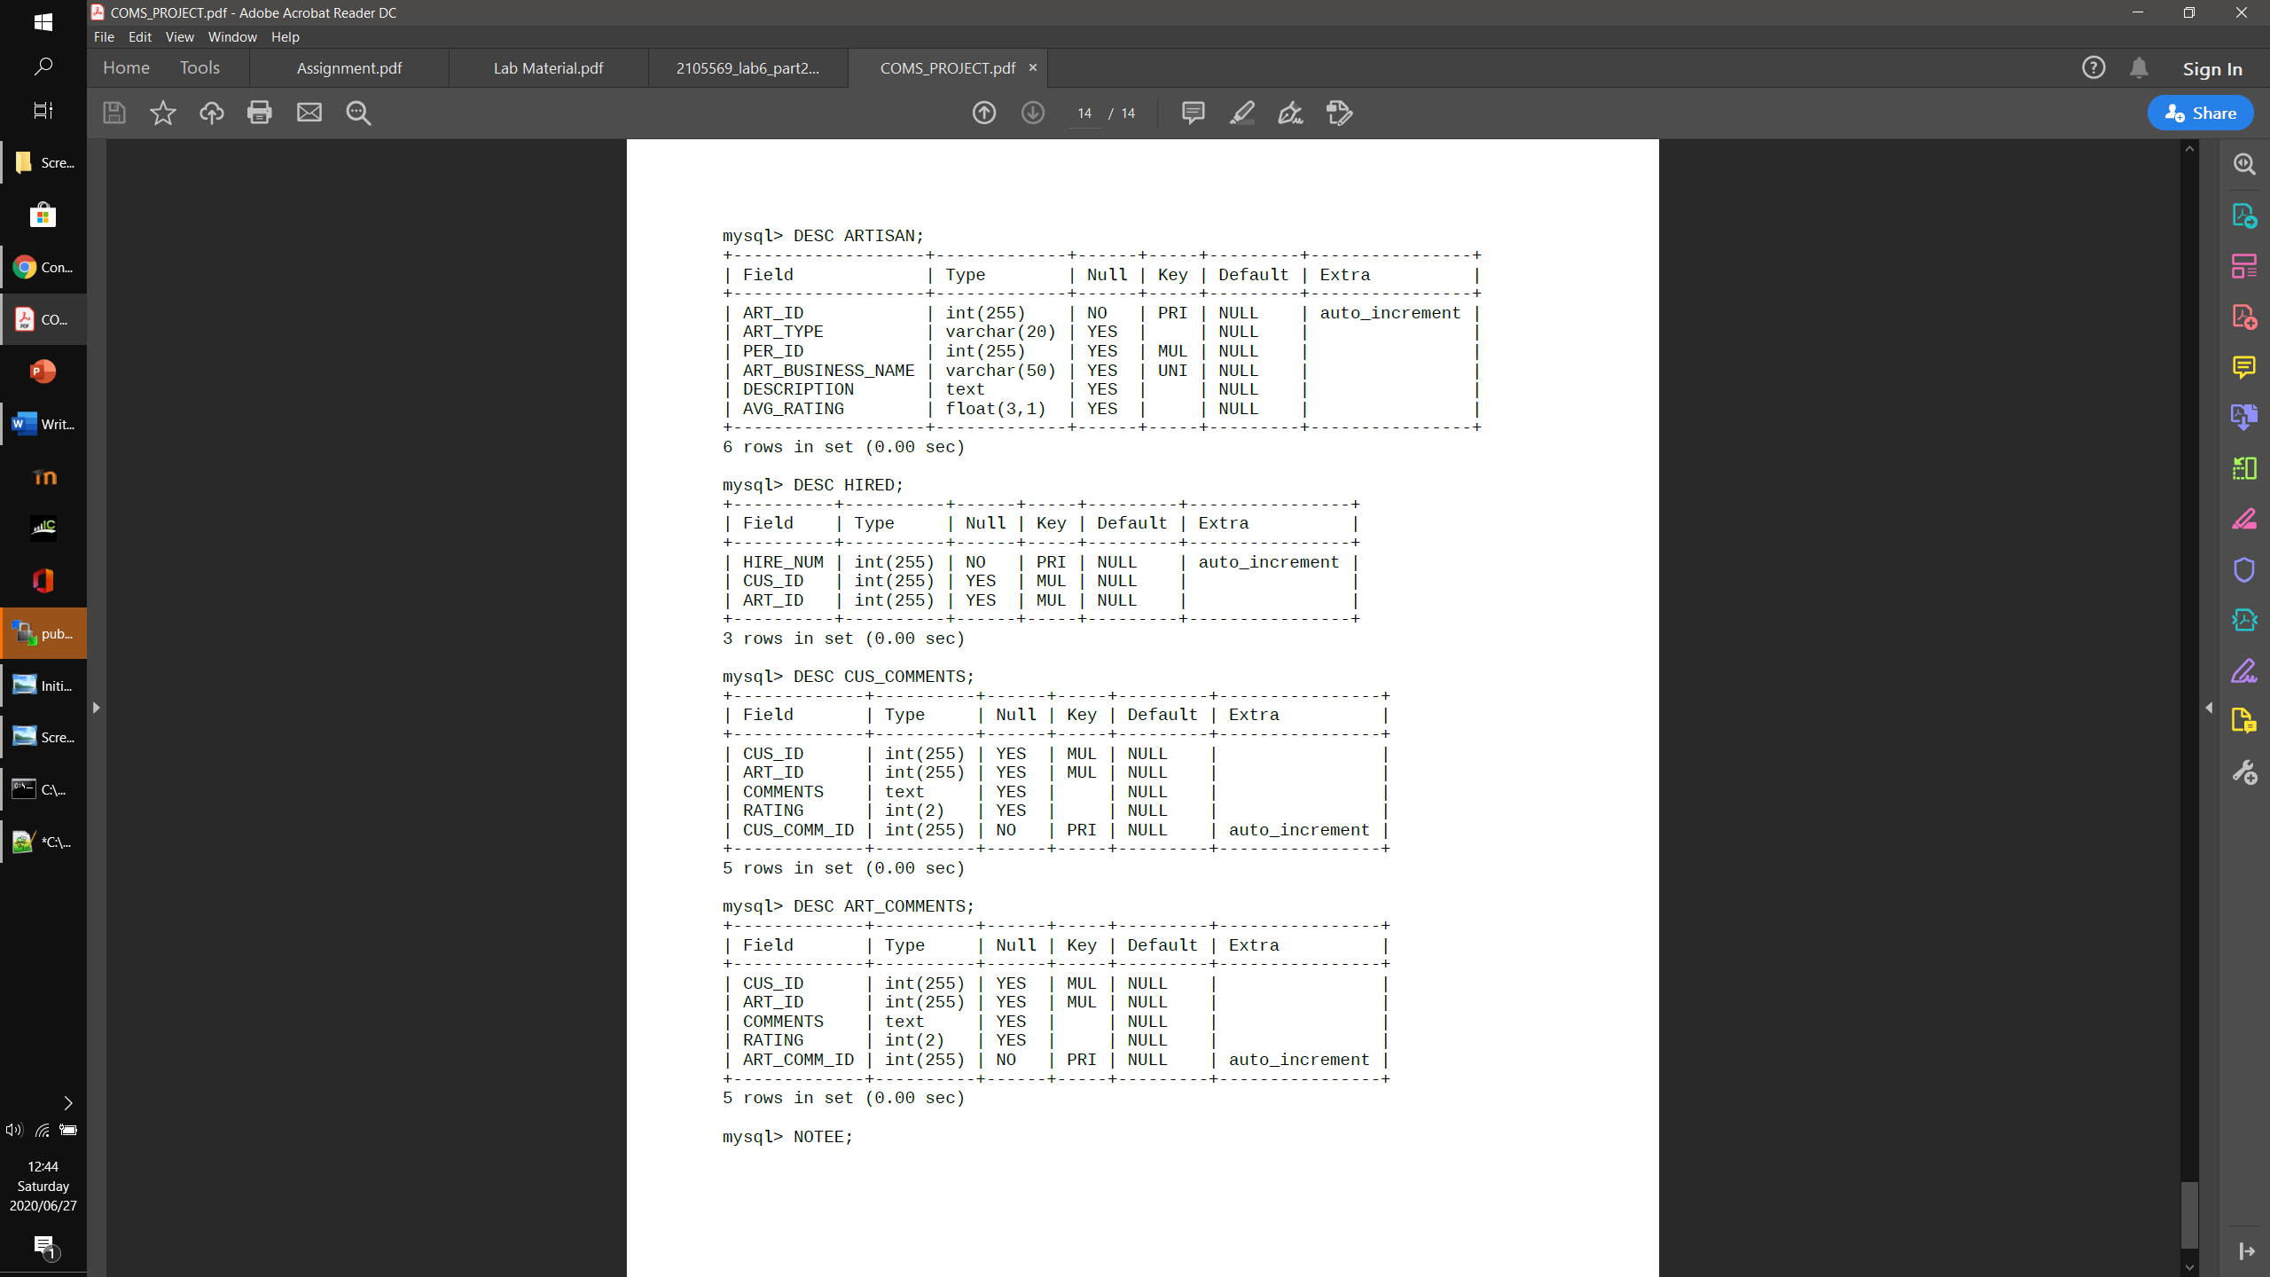

Procedures used:
mysql> DELIMITER //
mysql> CREATE PROCEDURE INSERT_ART(USER CHAR(1),TYPE VARCHAR(20),DESCRIP TEXT(1024),NAME VARCHAR(50))
-> BEGIN
-> DECLARE person_id INT;
-> SELECT MAX(PER_ID) INTO person_id FROM PERSON;
-> IF (USER = "A") THEN
-> INSERT INTO ARTISAN(ART_TYPE,PER_ID,ART_BUSINESS_NAME,DESCRIPTION) VALUES(TYPE,person_id,NAME,DESCRIP);
-> END IF;
-> END;
-> //
Query OK, 0 rows affected (0.00 sec)
After inserting into PERSON, this procedure is then called to check if the subtype discriminator is equal to A if it is it will use the rest of the data in the php file to create an instance of the user in the ARTISAN table.
mysql> CREATE PROCEDURE AVG(person_id INT)
-> BEGIN
-> DECLARE avg FLOAT;
-> SELECT AVG(RATING) INTO avg FROM CUS_COMMENTS WHERE ART_ID = person_id;
-> UPDATE ARTISAN SET AVG_RATING = avg WHERE ART_ID = person_id;
-> END;
-> //
Query OK, 0 rows affected (0.00 sec)
This procedure is used to calculate and update the average rating of an artisan

Triggers used:
mysql> CREATE TRIGGER INSERT_PER
->AFTER INSERT ON PERSON
->FOR EACH ROW
->BEGIN
->DECLARE person_id INT;
->SELECT MAX(PER_ID) INTO person_id FROM PERSON;
->INSERT INTO CUSTOMER(PER_ID) VALUES(person_id);
->END;
->//
Query OK, 0 rows affected (0.05 sec)
This trigger is used to create an instance of a customer after they are add to the person table.

mysql> CREATE TRIGGER BEFPER
-> BEFORE INSERT ON PERSON
-> FOR EACH ROW
-> BEGIN
-> IF NEW.PER_PHONE = "" THEN
-> SET NEW.PER_PHONE = NULL;
-> END IF;
-> IF NEW.PER_EMAIL = "" THEN
-> SET NEW.PER_EMAIL = NULL;
-> END IF;
-> END;
-> //
Query OK, 0 rows affected (0.05 sec)
This trigger checks if a primary key value is empty. If it is it sets the value to NULL before inserting into the table.

mysql> CREATE TRIGGER INSERT_AVG
-> AFTER INSERT ON CUS_COMMENTS
-> FOR EACH ROW
-> BEGIN
-> CALL AVG(NEW.ART_ID);
-> END;
-> //
Query OK, 0 rows affected (0.06 sec)
This trigger is used to call the AVERAGE procedure to calculate the average rating of the artisan who just got commented on
mysql> DELIMITER //
mysql> CREATE TRIGGER BEFUPPER
->BEFORE UPDATE ON PERSON
->FOR EACH ROW
->BEGIN
->IF NEW.PER_PHONE = "" THEN
->SET NEW.PER_PHONE = NULL;
->END IF;
->IF NEW.PER_EMAIL = "" THEN
->SET NEW.PER_EMAIL = NULL;
->END IF;
->END;
->//
Query OK, 0 rows affected (0.06 sec)
This trigger works like BEFPER trigger but this trigger is called on update of PERSON table

Peer Review

Peer review from Tristan:
Sheslin contributed 50% of the overall project. So, where I designed and coded the app side of the login screen, registration screen and update profile screen he did the php files for those activities. And where he designed the other activities(such as view profiles, add comments or search for artisans ), I would do the php files for him. This allowed us to be 100% integrated in each other’s work and allowed both of us to be equally involved in every aspect of the project.

*Sheslin’s peer review can be found in his upload of the project*

